INTERCOM discrepancy

In Kropff & Laar (1993), p. 42 we have the absorption of the three kinds of fluxes in the canopy (indexed df, drt, drdr) for the i’th component of the canopy at height j:

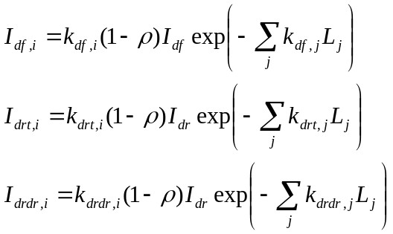 (eqs. 4.15-4.17)

where ρ is the reflected fraction of light.

However, in the FORTRAN code on p. 227, the term

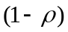

has three different formulations, depending on the type of light, named REFVH, REFVS and SCV. Rewriting equations 4.15-4.17 to make them correspond with the FORTRAN code, we get

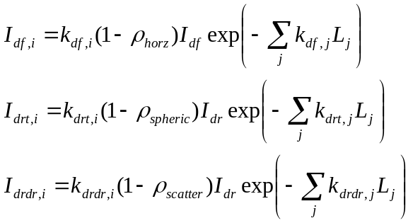
where
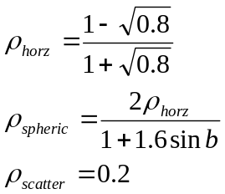

The common ρ used on p. 42 was defined on p. 38 and is equal to ρ_{spheric} using the notation above.

Niels
14 July 2010.

